1. Each company hires at least one employee; and an employee cannot work for more than one company. Each company must have at least one project; a project must be organized by at least one company. An employee may or may not work in several projects; each project must have at least one employee.

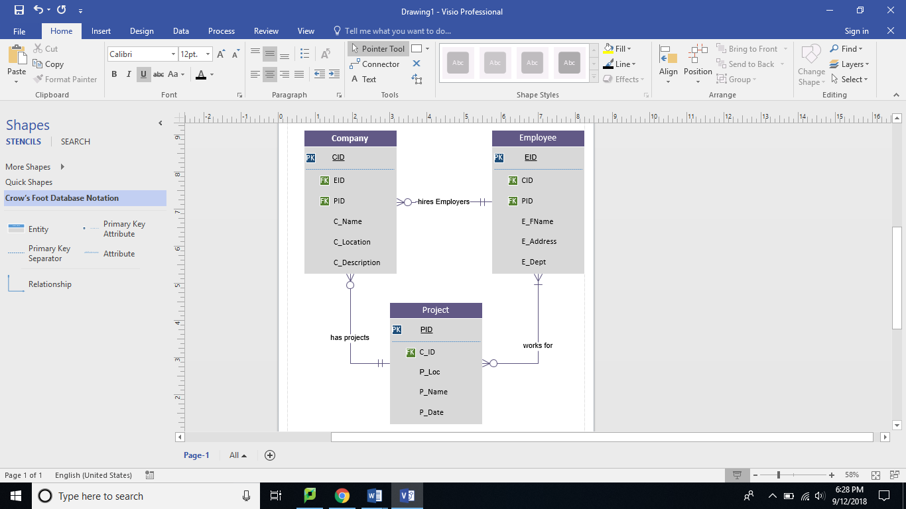

2.The following example is for Dining halls in Syracuse University.In this example, we’ll understand the key members of Dinning hall and relationships between them.

Business rules are as follows:

* Dinning halls has at least one student employee and at least one commercial employee.
* Students can visit any of the dinning halls and student may or may not be a student employee.
* Student employees can work in more than one dinning hall.
* Commercial employee can work in one or more than one dinning hall and cannot be a student.
* Student Employee has to be enrolled in one or more courses in SU.
* Student has to enroll in at least on course and courses should hve one or more students.
* Student may or not be an employee.
* Courses can have zero student employee.

